Sales App User Guide



Version: 1.0

Date: 09/272023

Created by: Felipe Ramirez

Table of Contents

1. Login and App Interface 3

2. Home 4

3. Admin Page 4

4. Technical Design (Create): 5

5. Tally Design (Create): 20

6. Technical Design and Tally Design (List): 21

7. Wells Page 23

8. Clients Page 25

9. Sales Page 27

10. Simulators 28

# Login and App Interface

* 1. Go to <http://salesapp.odessaseparator.com/>
  2. Login to the app, with the correspondent credentials



In case you do not have credentials please ask them to the following emails:

* [jramirez@odsep.com](mailto:jramirez@odsep.com), [ggonzalez@odsep.com](mailto:ggonzalez@odsep.com)
  1. When logging the app redirects to the homepage, sidebar displays the options according to your role, all pages will be structured as follows:

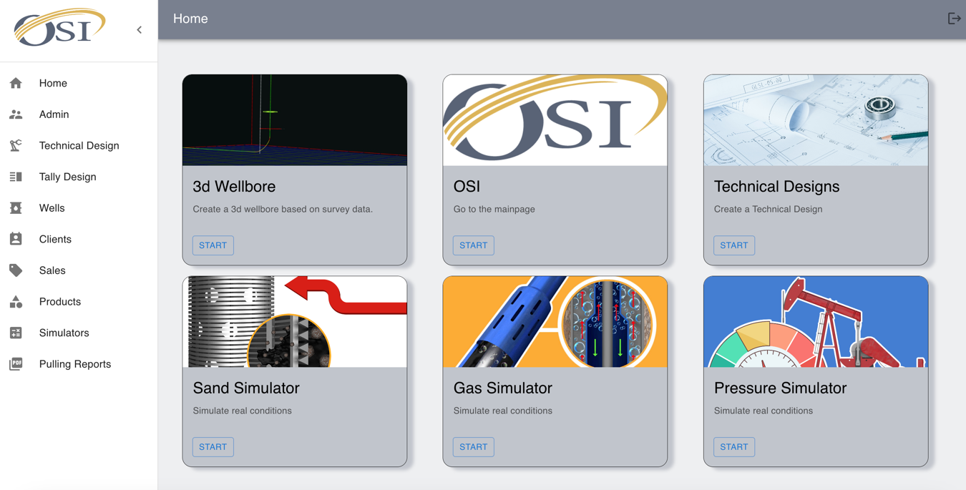

Logout Button

Page Content

Side navbar

Top navbar

# Home

This page will give you some shortcuts to different external and internal resources depending on your role into the system.

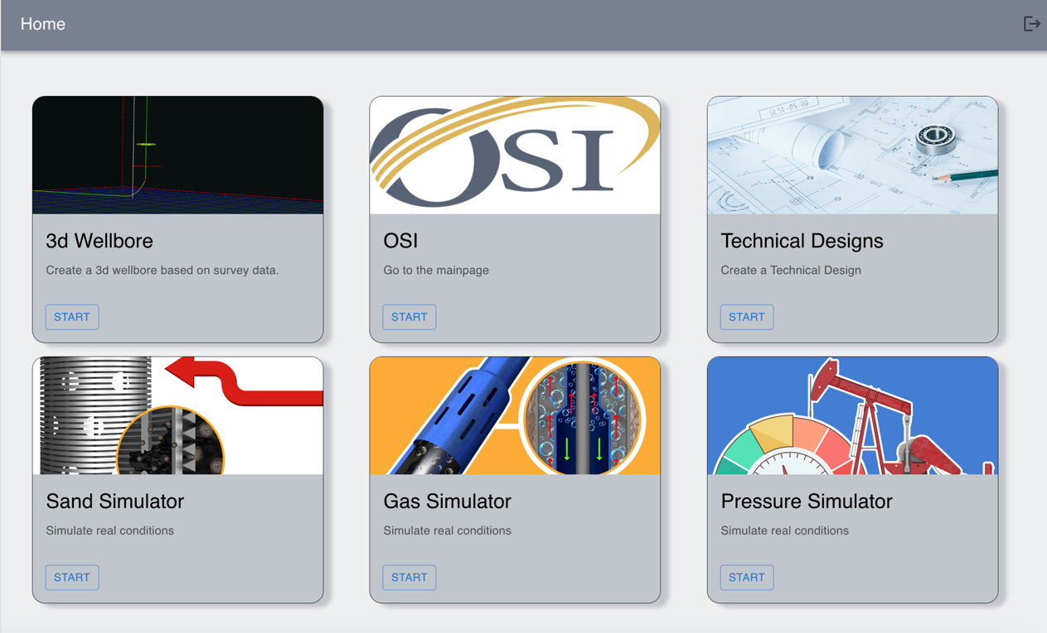

* 3d Wellbore (External): Redirects to <https://3dwellbore.com/>
* OSI (External): Redirects to <https://www.odessaseparator.com/>
* Technical Designs (Internal): Redirects to Technical Designs list
* Sand Simulator, Gas Simulator, Pressure Simulator (Internal): Redirects to app Simulators

# Admin Page

This page allows Admin users to set up different options along the app (not detailed).

# Technical Design (Create):

This section explains how to list and create technical designs under OSI standard:

* Click on “Technical Design” and then click on “Create” first option.

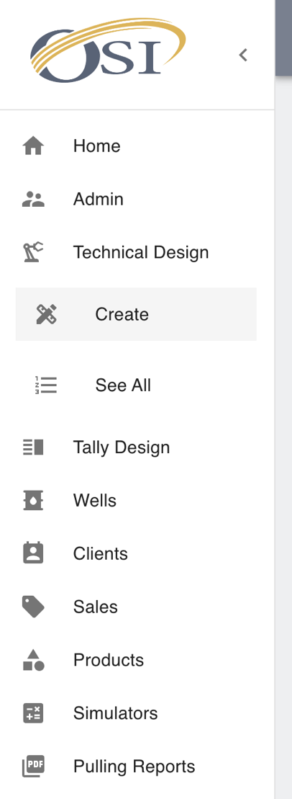

* On the following form type technical design data:

Options

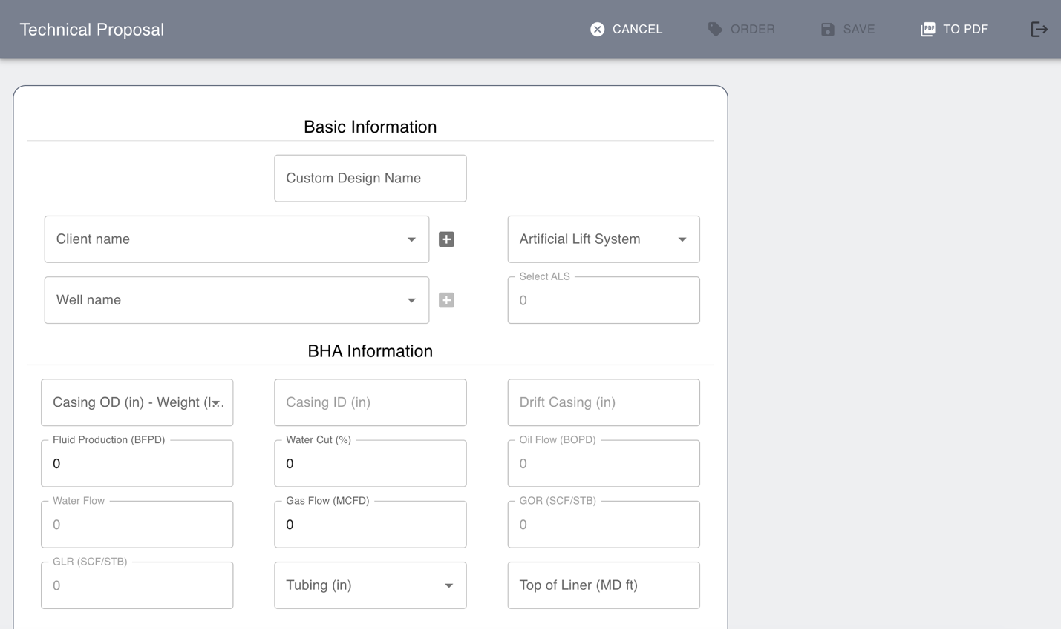

Form

Options: Some options are disabled depending on the status of the technical design

* **Cancel**: To go back to the previous page
* **Order**: To create a sales order after form submitting.
* **Save**: To save technical design after all fields are filled out.
* **To PDF**: To export data into a PDF file.

Form:

* 1. Basic Information

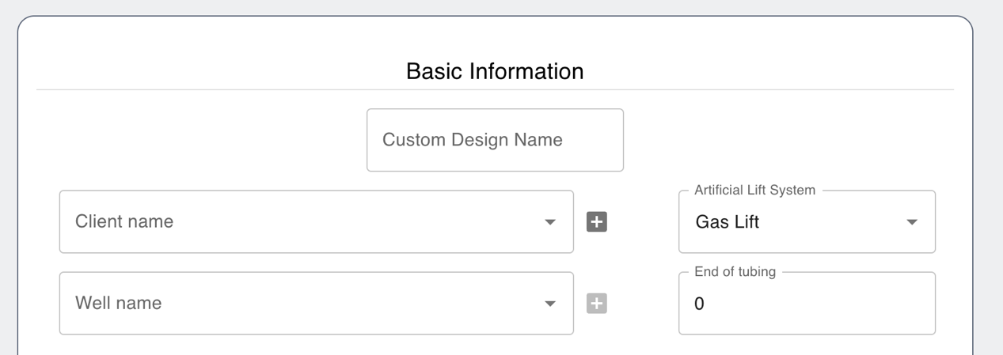

- **Custom Design Name** (Text Field): Name of the technical design to make it easy to identify from the list.

- **Client Name** (Selector): List of the OSI clients (Select one).

- **Well Name** (Selector): List of the wells associated with the selected OSI client (Select one).

- **Artificial Lift System** (Selector): List of the artificial lift system (Select one).

- **Seating Nipple, Sensor Depth, End of tubing, Pump depth** (Number field): This field depends on the Artificial Lift System selected and will be the initial point to start making the design in the tally model.

* 1. BHA Information

- **Casing OD – Weight** (Selector): Select one depending on the BHA design of the client.

- **Casing ID** (Autogenerated): Depends on the casing OD.

- **Drift Casing** (Autogenerated): Depends on the casing OD.

- **Fluid Production** (Number Field): Amount of fluid produced by the well per day (BFPD).

- **Water Cut** (Number Field): Percentage of water present in the fluid production.

- **Oil Fluid** (Autogenerated): Depends on the Fluid Production and water cut.

- **Water Fluid** (Autogenerated): Depends on the Fluid Production and water cut.

- **Gas Flow** (Number Field): Gas flow measured in MCFD produced in the well.

- **GOR** (Autogenerated): Depends on the fluid production and gas flow.

- **GLR** (Autogenerated): Depends on the fluid production and gas flow.

- **Tubing** (Selector): List of the tubing diameter.

- **Top of Liner** (Number Field): Fill out with the information of the well.

* 1. Additional Information

- **Well Classification** (Selector): List of the types of wells (conventional of unconventional)

- **TAC above SN** (Selector): When Rod Pump is selected as ALS, If TAC is located above seating nipple select “Yes.”

- **Sand fallback Equipment above the pump?** (Selector): When ESP is selected as ALS, if any sand fallback equipment (ex. Sand lift) is located above the pump select “Yes.”

- **Gas Lift Options** (Selector): When Gas lift is selected as ALS, you must select one of the two options of this list (Packerless, Packer)

- **Flow** (Selector): When Gas lift is selected as ALS, you must select if it is annular flow or tubing flow.

* 1. Production History

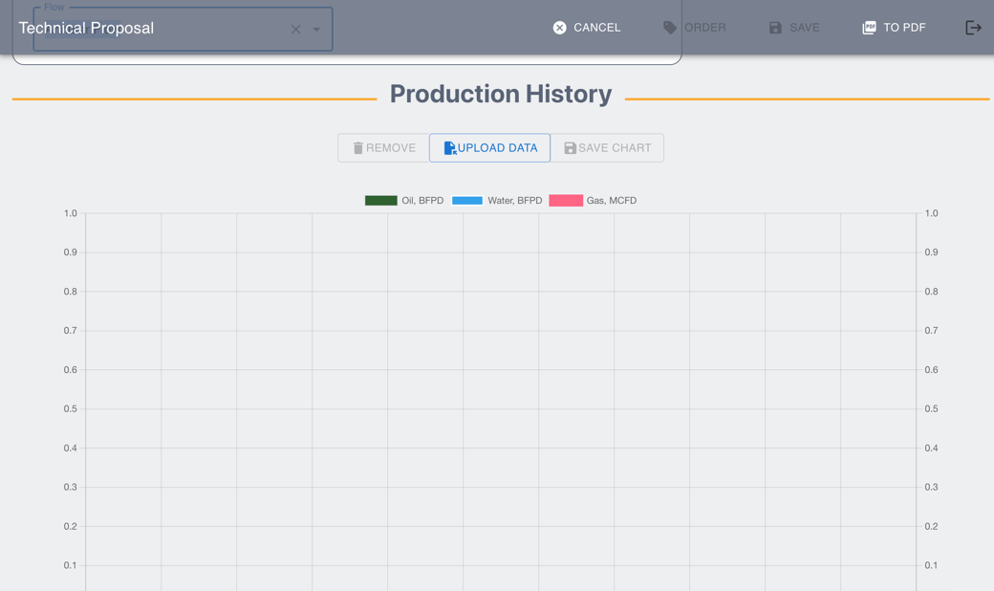

This section allows the user to upload production data from excel file. This data must be in the following format:

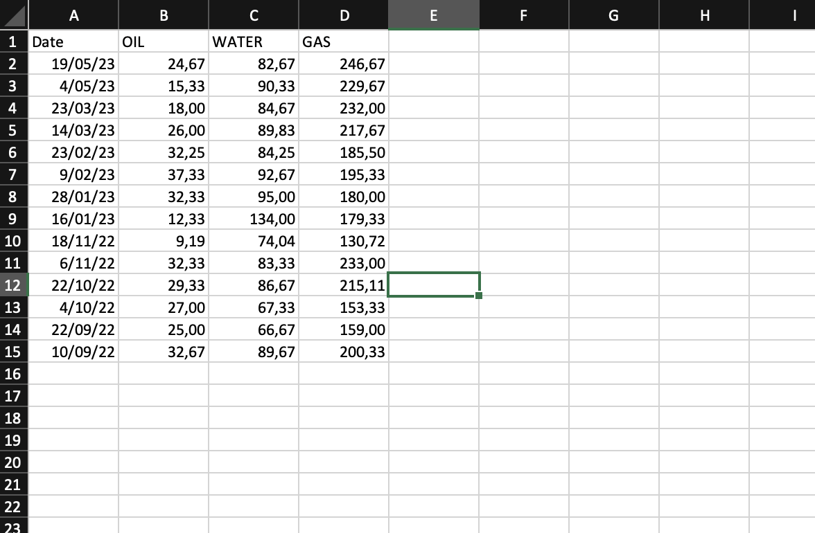

* Date (String with date format)
* OIL (Number)
* WATER (NUMBER)
* GAS (NUMBER)

To upload a file, click on “Upload data” Button.

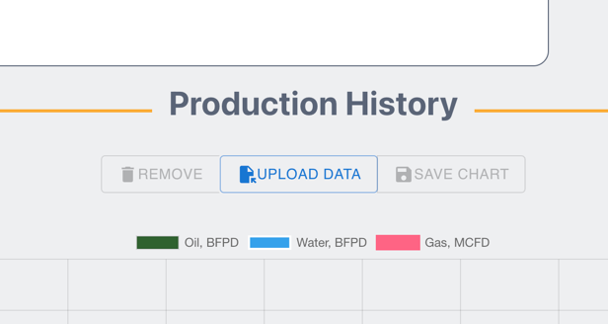

After uploading excel file in the correct format, you must be able to see a graphic:

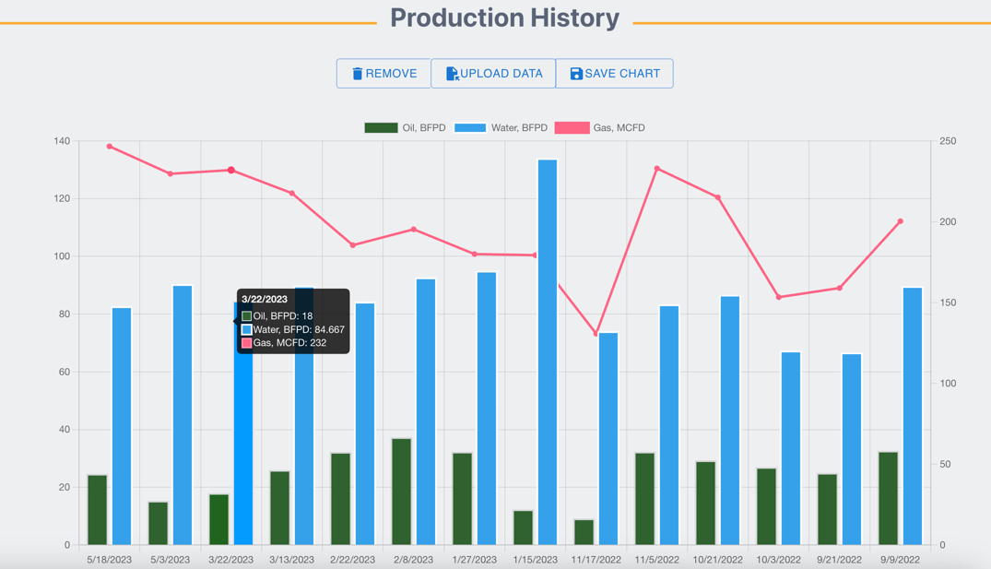

To Save data click on “Save Chart” Button.

To Remove data, click on “Remove” Button.

* 1. Simulation

This section allows the user to add gas, sand or pressure drop simulators to the technical design. To start any simulator, click on start button.

The color gray in the background of the card of every simulator, means that the simulator is not currently in use.

After you start any simulator, it should change the background color which means is being added to the technical design, you can remove it or edit it from the buttons:

* + 1. Gas Simulator

There are three types of simulators for gas behavior:

* G Force Packerless
* Packertype
* Poor boy

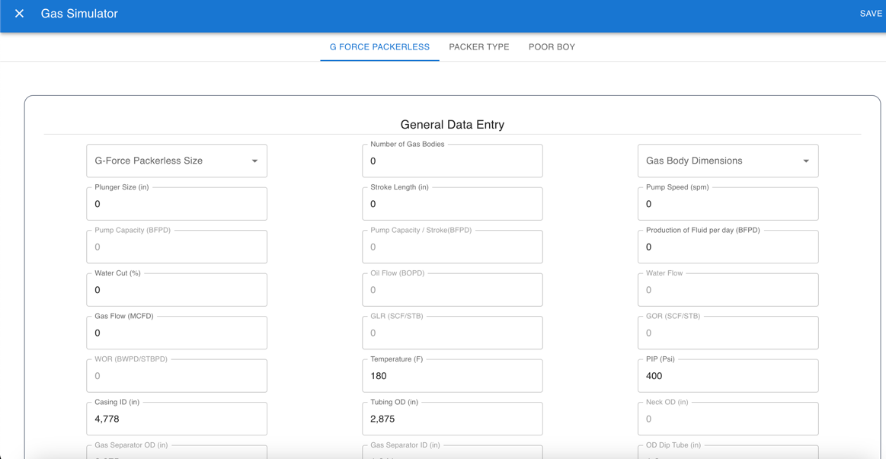

After you filled out all the form, click on the “Simulate” Button at the bottom of the page:

The result of the simulation must be displayed in the following section:

* + 1. Sand Simulator

In this case, sand simulator has three options:

- Tubing Screen

- Pump Guard

- Super Perf

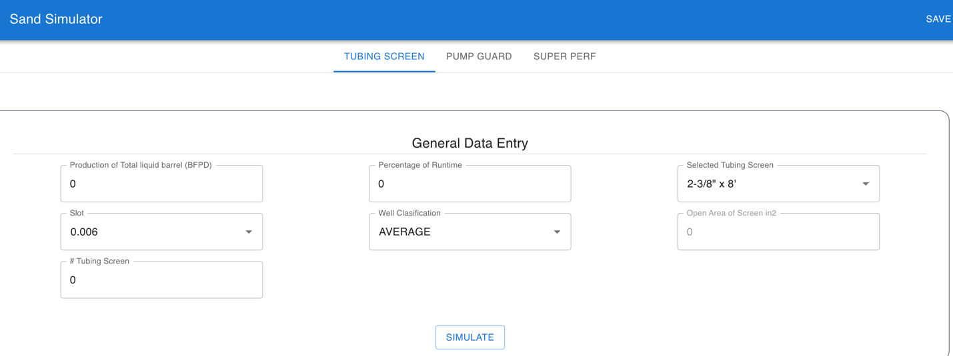

After you filled out all the form, click on the “Simulate” Button at the bottom of the page:



The result of the simulation must be displayed in the following section:

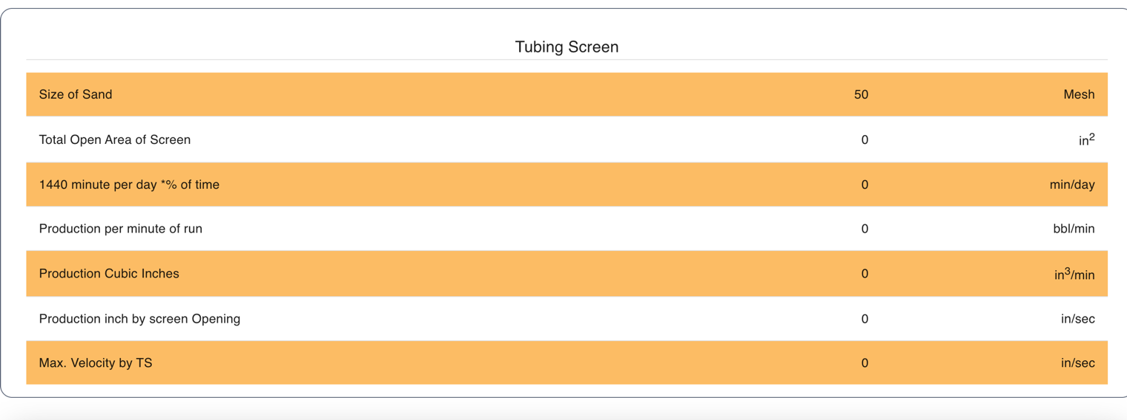

* + 1. Pressure Drop simulator:

This section has 2 options:

- Dip tube

- Screen

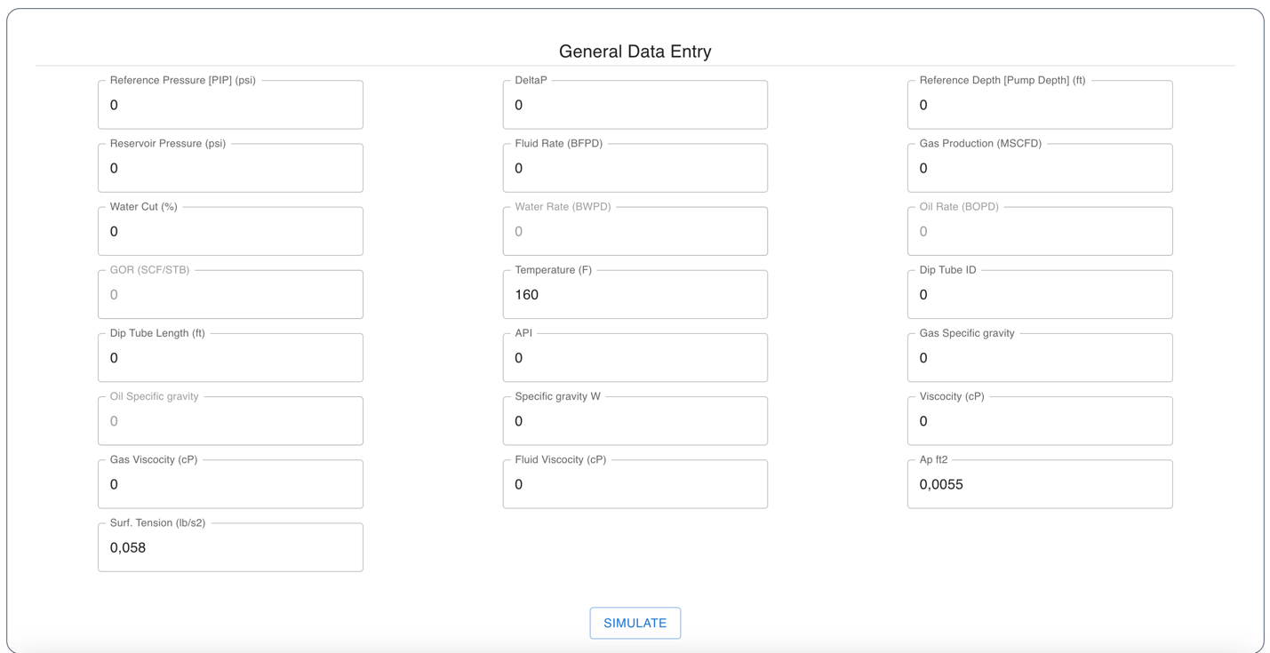

After you filled out all the form, click on the “Simulate” Button at the bottom of the page:

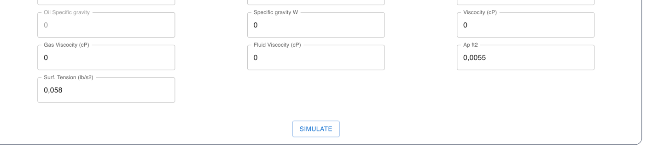

The result of the simulation must be displayed in the following section:

* 1. 3D Wellbore

This section allows the user to upload 3D wellbore image:

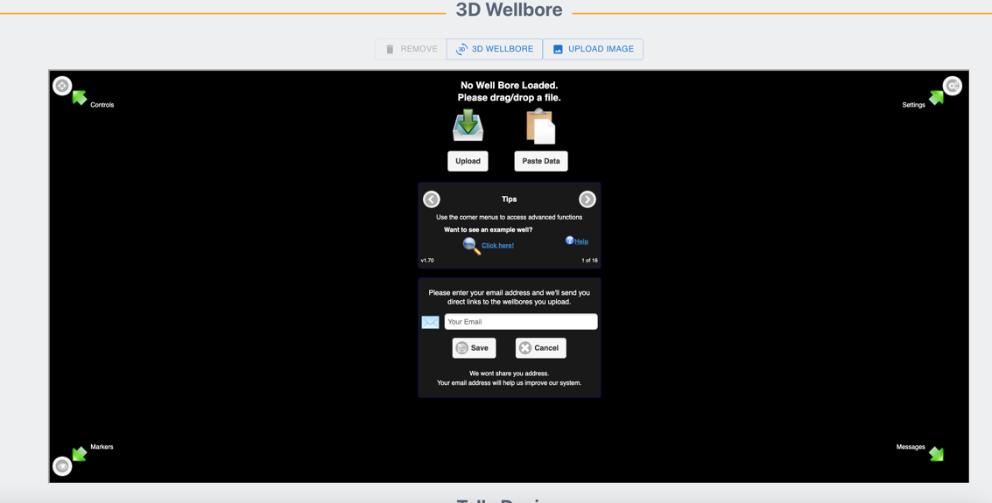

User can also use the embedded section of the 3D wellbore page.

To upload an image, click on the “Upload Image” button:

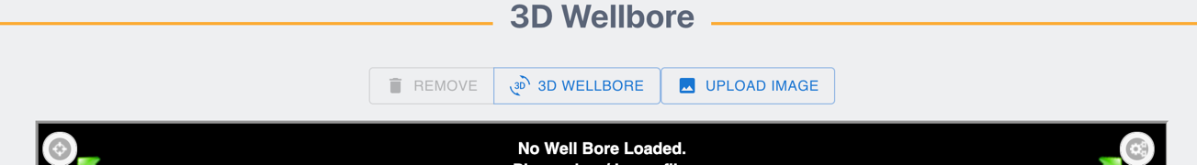

After select your .png or .jpg file, the image is displayed:

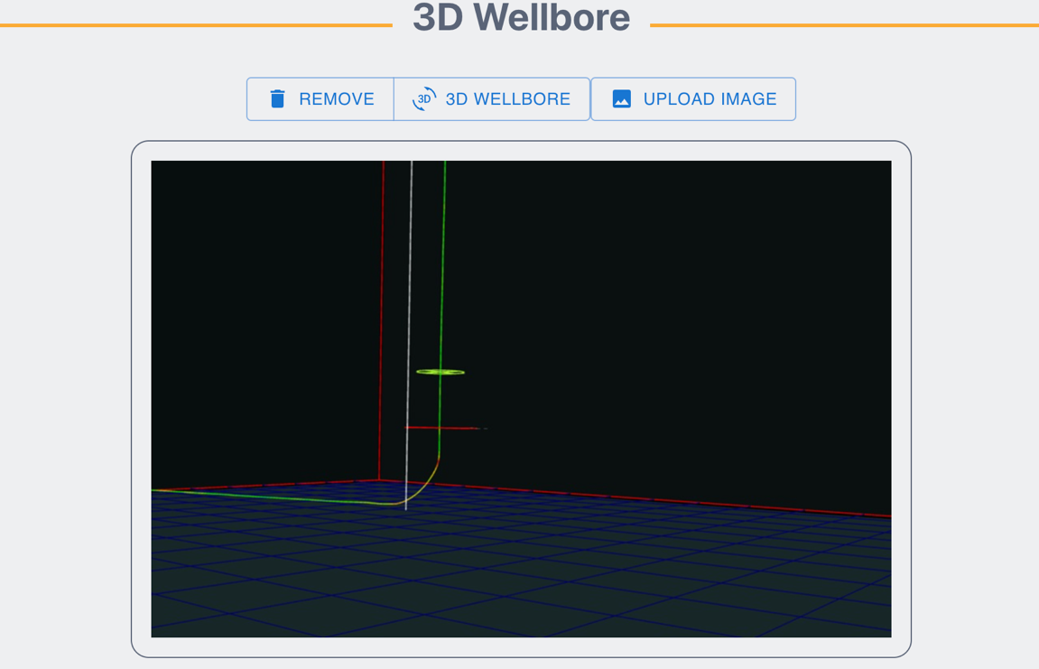

* 1. Tally Design

In this section, user can add tools to the design:

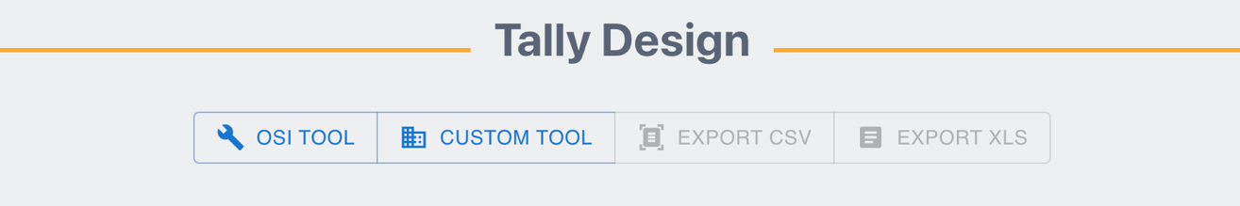

* To add a tool manufactured by OSI, click on the “OSI TOOL” Button
* To add a tool that is provided by a third party (Ex. ESP Assembly, Seating nipple, Mechanical packer, Tail Joints), click on the “CUSTOM TOOL” Button.
* The “EXPORT CSV” button will enable after a tool is added.
* The “EXPORT XLS” button will enable after a tool is added.
  + 1. Adding a OSI tool
* Click on the “OSI TOOL” Button

A new row will be added to the tally design table:

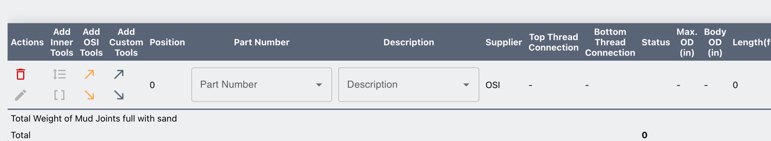

To search a tool, user can user Part number selector or Description selector.

* Search for a tool by part number by typing part number on the selector:

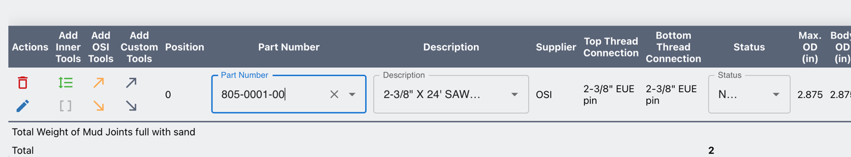

The information of the tool will be automatically filled.

* The section rounded in the following image has different buttons that allow the user to commit different actions:



|  |  |  |
| --- | --- | --- |
| Icon | Name | Action |
|  | Remove Row | Removes the entire row |
|  | Edit Product | Edit tool data in the database |
|  | Add Inner tool | Allows to add a tool that will not be put above or under any tool (Ex. Centralizer, dip tube) |
|  | Inner tool details | Used to see the detailed of the previously added inner tool (from this option you can also remove the inner tool |
|  | Add OSI tool | To add rows that will display autocomplete fields with OSI product list |
|  | Add Custom tool | To add rows that will display autocomplete fields with Custom product list |

After adding all tools to the design, user can download the table in XLS or CSV format by clicking on the buttons located on the top and the bottom of the “Tally Design”:

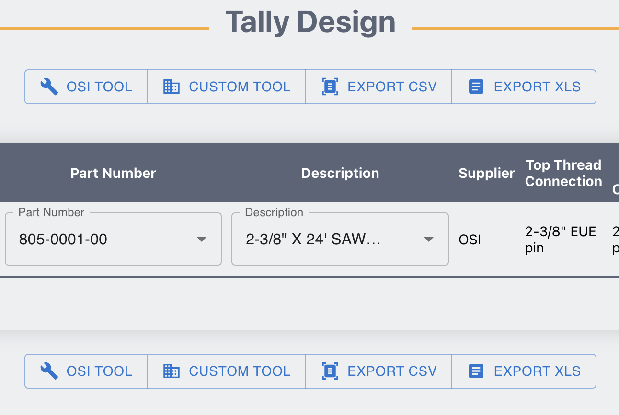

* 1. Wellbore Design

In this section user can change the size of the image that will be displayed in the exported PDF file:

After adding tools to the tally design, the images must be displayed as follows:

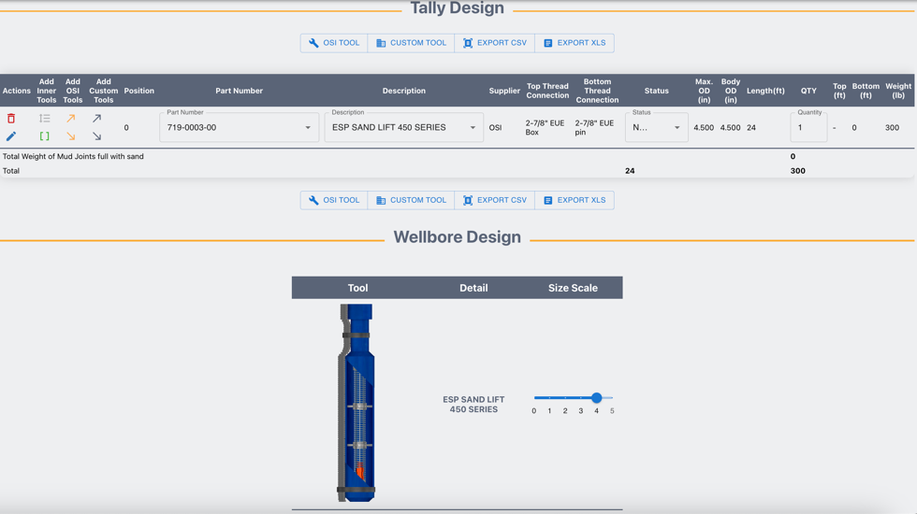

In the above example a sand lift was added into the tally design and that action automatically adds a row to the wellbore design, this section has 3 sections:

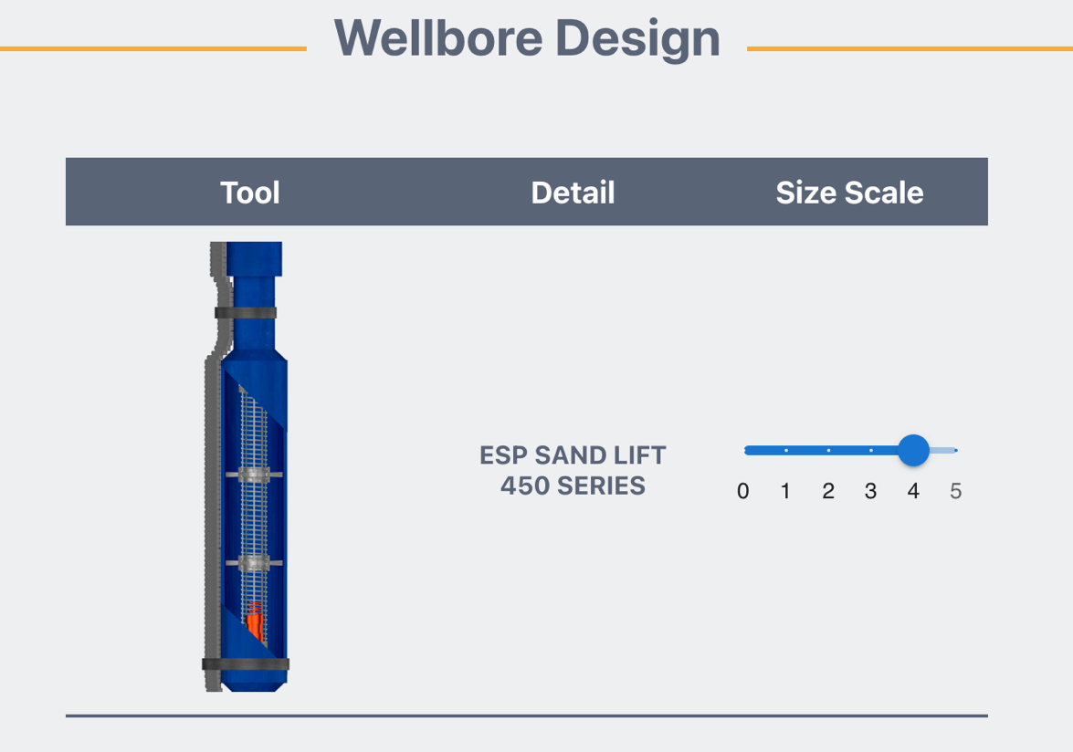

Tool Image

Tool Name

Size Scale

If user wants to change:

1. Tool Image: contact support with the correct image by sending an email to [jramirez@odsep.com](mailto:jramirez@odsep.com)
2. Tool Name: In the “Tally Design” section user can edit the tool details.
3. Size scale: Move right or left the size scale field it will increase or decrease the size that the tool uses in the PDF file.
   1. Export to PDF

When all the technical design form is filled, click on the “Save” Button

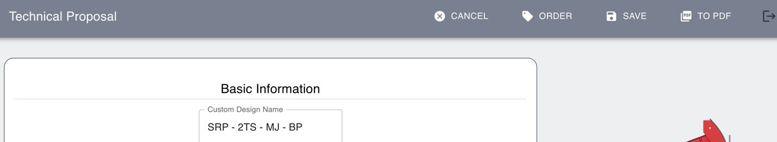

To export to PDF, click on the “To PDF” button:

After that, a PDF preview must be displayed, you can download by clicking on any of the “Download” buttons:

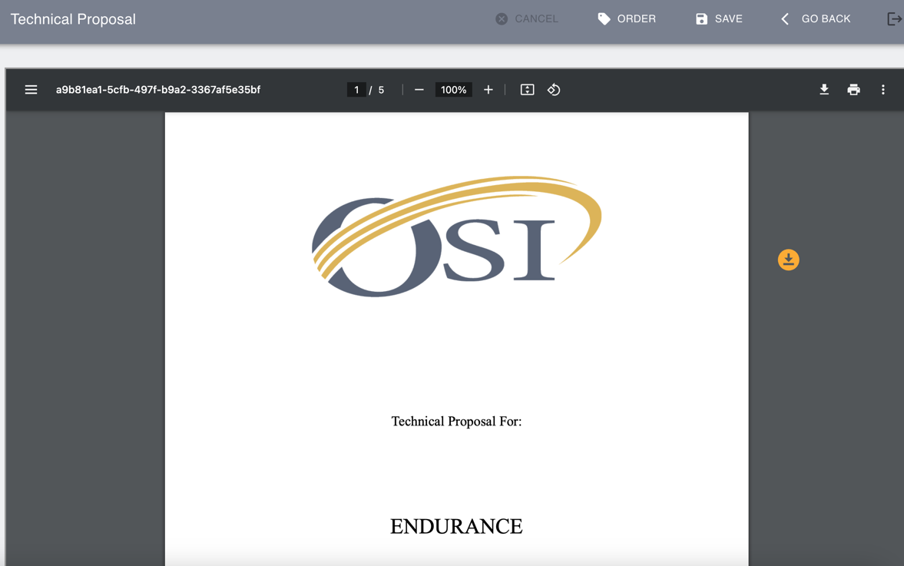

This will generate a PDF file with the standard format using by the technical department at OSI.

* 1. Generate Sales Order

To automatically generate Sales order from technical proposal, click on the “Order” Button:

That action will redirect the user to the Sales order form page, where all the sales order data can be added:

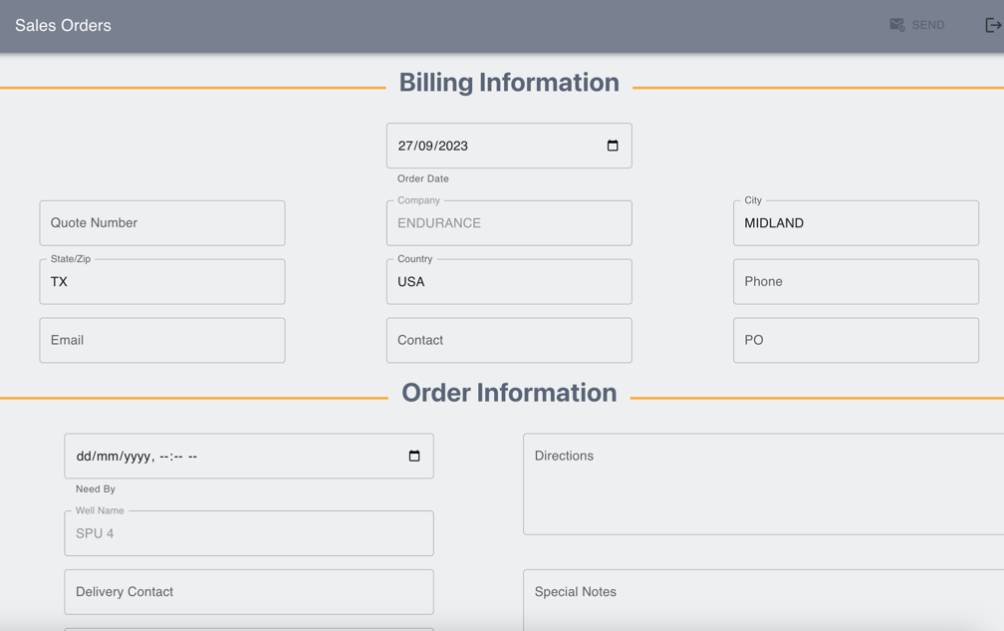

This form has automatically added the list of the products to be send to the client:

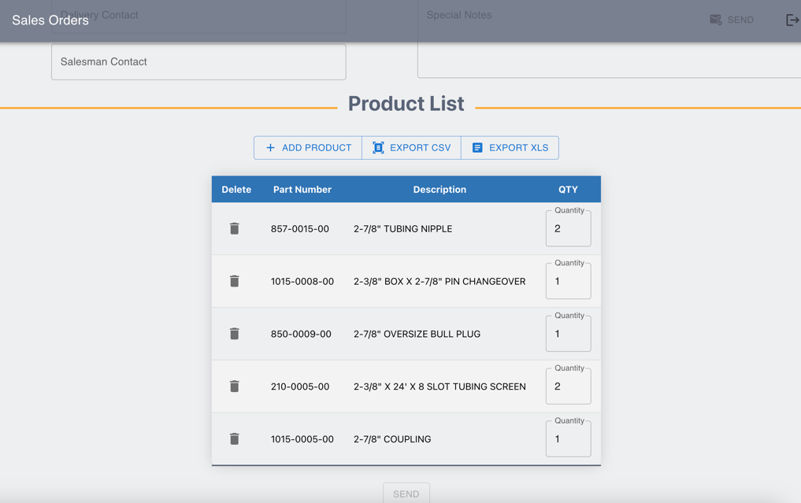

After completing this form, click on the “Send” button at the top nav bar:

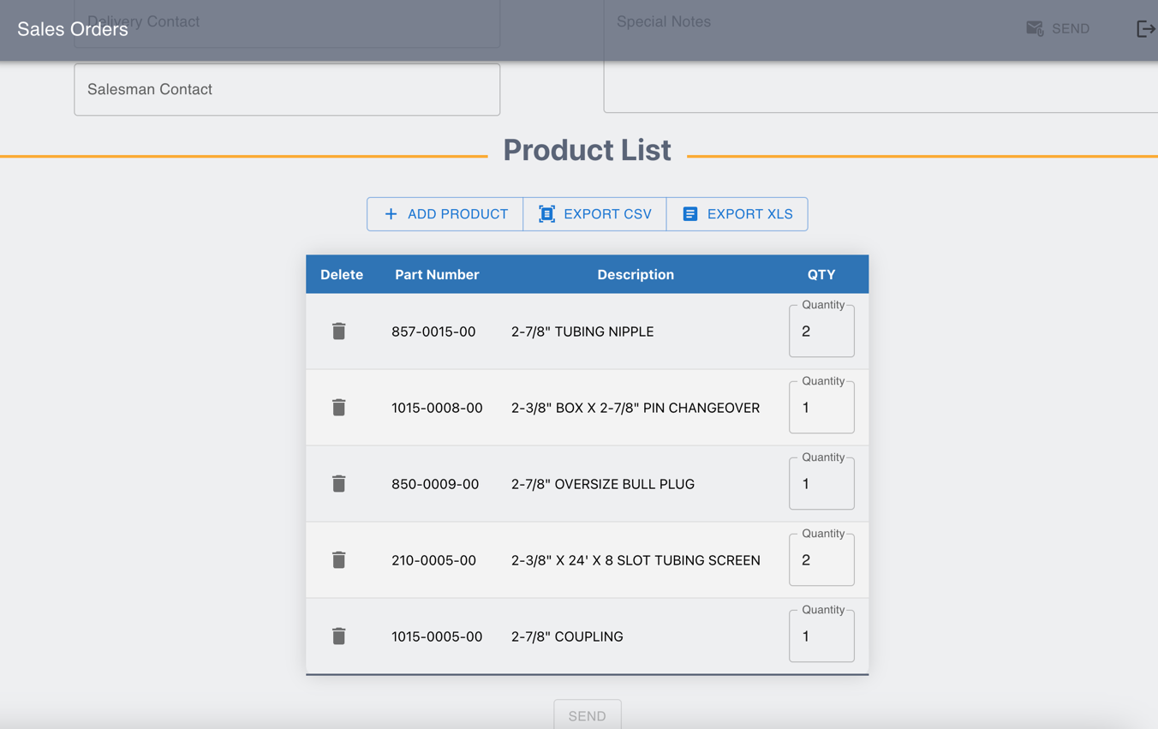

An email will be generated with all the Sales order information.

# Tally Design (Create):

This section is very similar to technical design section and allows the user to create tally design without production data, 3d wellbore and simulators.

* Click on the “Tally Design” option at the side navbar and then click on “Create.”

This action leads to the Tally & WBD form:

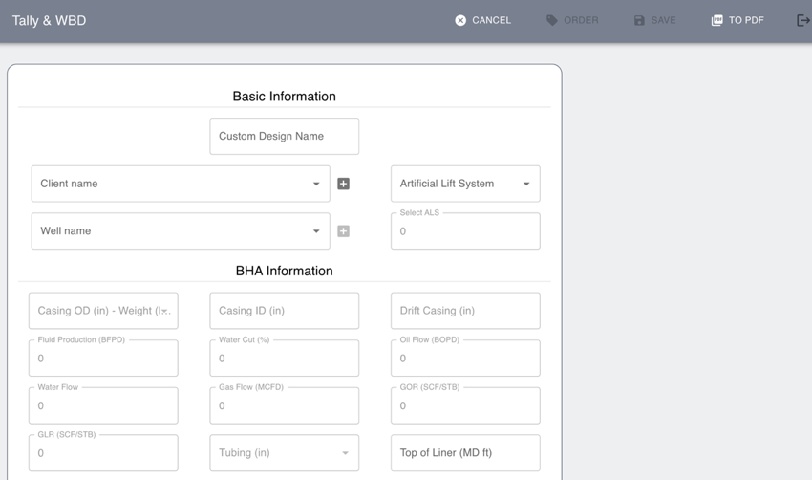

This form has the following sections:

* Basic Information
* BHA Information
* Additional Information
* Tally Design
* Wellbore Design

All the above section were already explained in the “Technical Design” creation guide.

Tally & WBD form allows the user to Save, export to PDF and create Sales order explained in the “Technical Design” creation guide.

# Technical Design and Tally Design (List):

Click on the Technical Design option at the side navbar and then click on the “See all” button:

Will be redirected to all technical designs created:

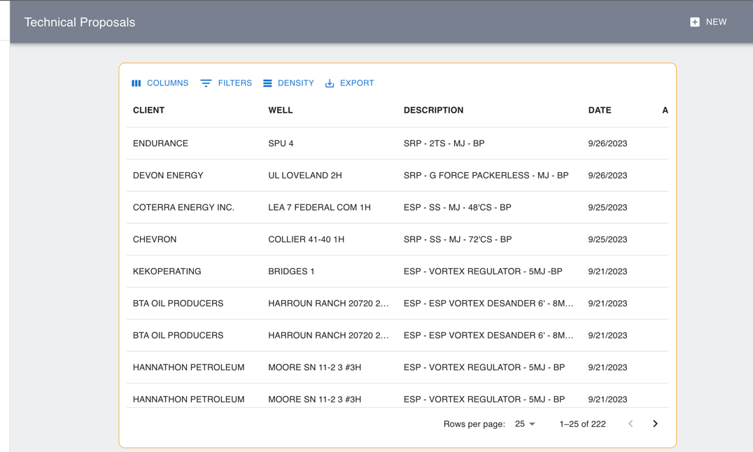

From this list, you can scroll right and see the actions available:

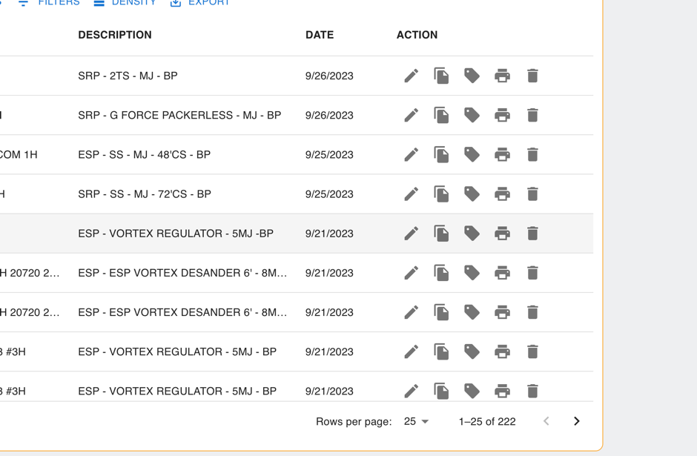

These buttons allow the user to:

* Edit Technical Design
* Duplicate Technical Design
* Create Sales Order from Technical Design
* Print Technical Design
* Delete Technical Design

# Wells Page

In this page, user can find a list of the wells associated with a client:

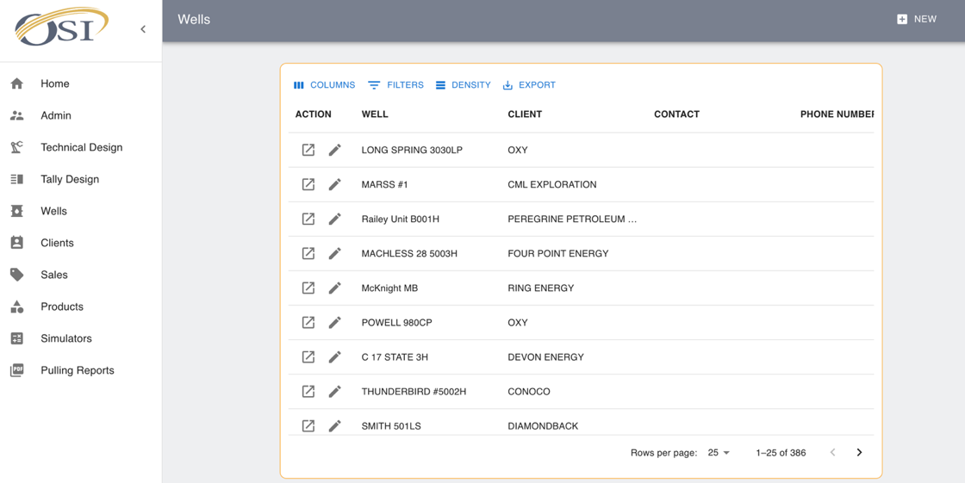

From this table you can edit or see detail of specific well by clicking on the buttons:

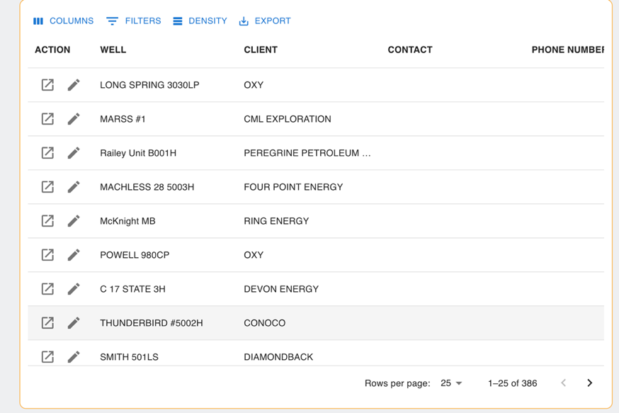

When clicking in the pencil button (Edit) a modal will be open with the main detail of the well:

If clicking on the detail button, will be redirected to well detail page, this page has the following sections:

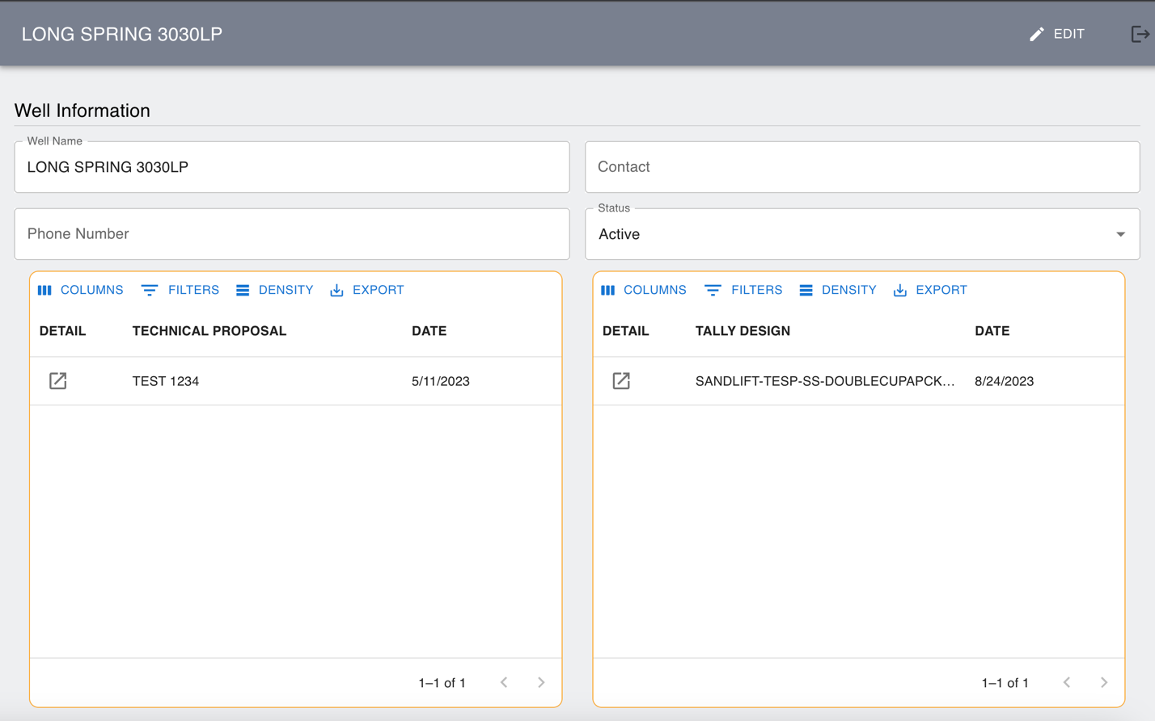

Actions

Technical Designs

Tally Designs

Well Info

# Clients Page

In this page, user can find a list of the clients:

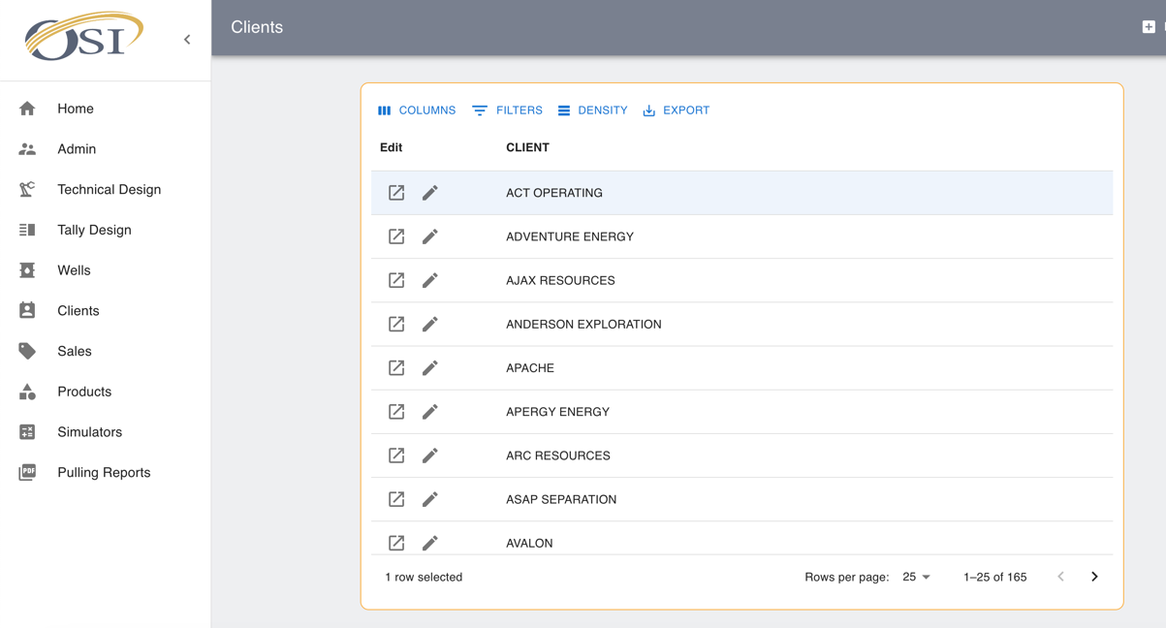

Table Detail:

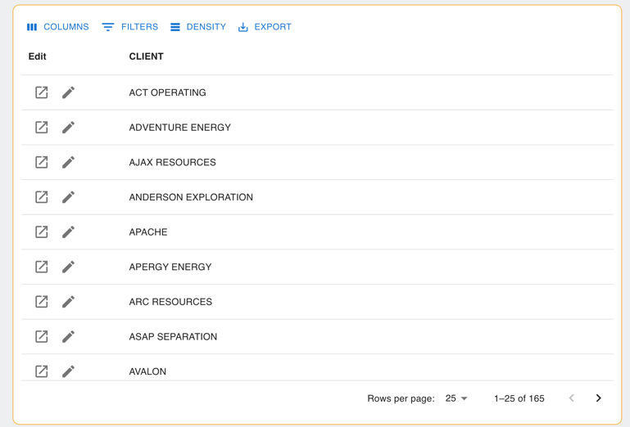

Actions

After clicking the edit button, a modal will be displayed with the name of the client to be changed if needed:

After clicking “Detail” button will be redirected to client page with the following sections

Client Details

Client’s wells

Actions

# Sales Page

In this page a table with a list of all sales order generated can be found.

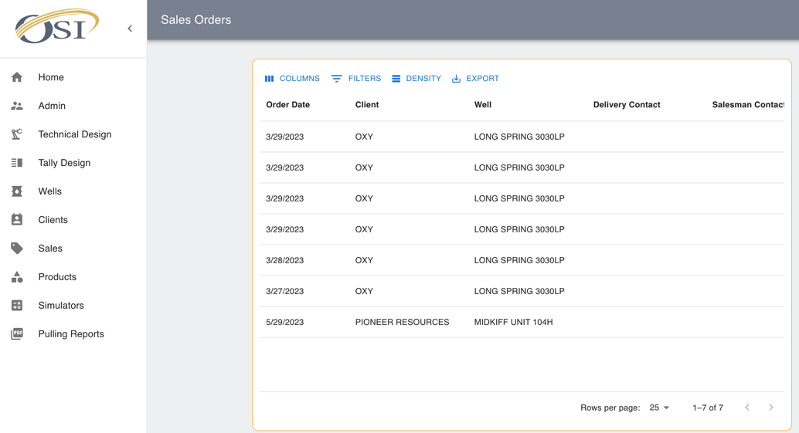

Actions will be displayed when scrolling to the right:

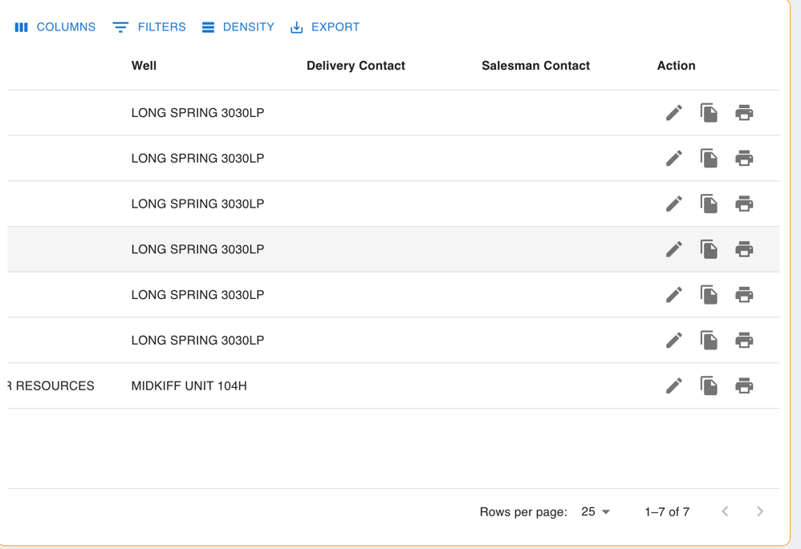

From this section you will be able to:

* Edit Sales Order
* Duplicate Sales Order
* Print Sales Order

# Simulators

This section allows the user to use simulators without creating any technical design.

**Sand Simulator:**

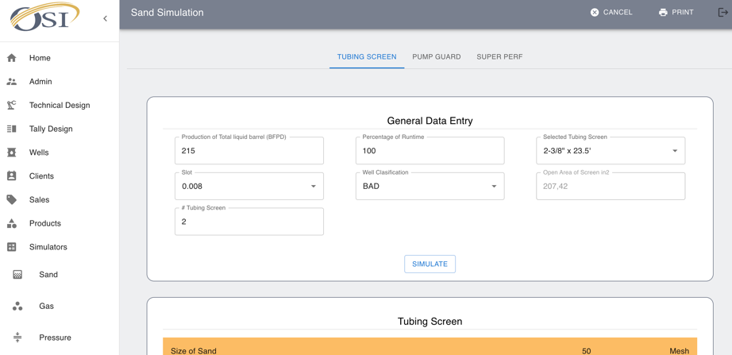

**Gas Simulator:**

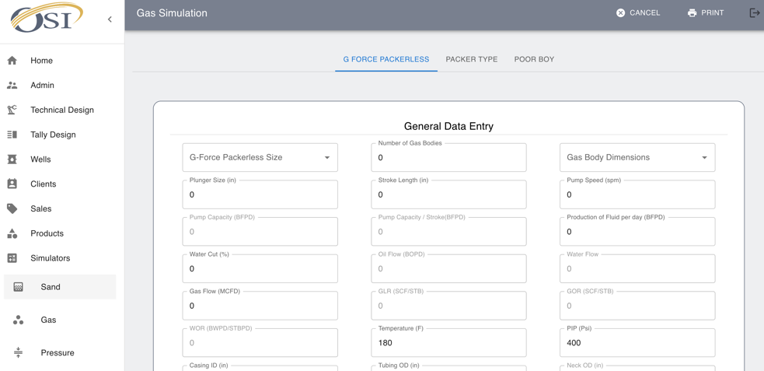

**Pressure Drop Simulator:**

